**Ideation Phase**

**Empathize & Discover**

|  |  |
| --- | --- |
| Date | 31 May 2025 |
| Team ID | LTVIP2025TMID43861 |
| Project Name | Transfer Learning-Based Classification of Poultry Diseases for Enhanced Health Management. |
| Maximum Marks | 4 Marks |

**Empathy Map Canvas:**

This Empathy Map Canvas helps us better understand the daily realities, struggles, and needs of rural and small-scale poultry farmers.

By exploring what they see, hear, think, feel, say, and do, as well as identifying their pains and gains, we build empathy and develop a solution that is both technically effective and emotionally relevant.

This insight-driven approach enables us to design a mobile-based AI tool that addresses real problems—making disease diagnosis faster, easier, and accessible, even in resource-limited settings.

**Example:**

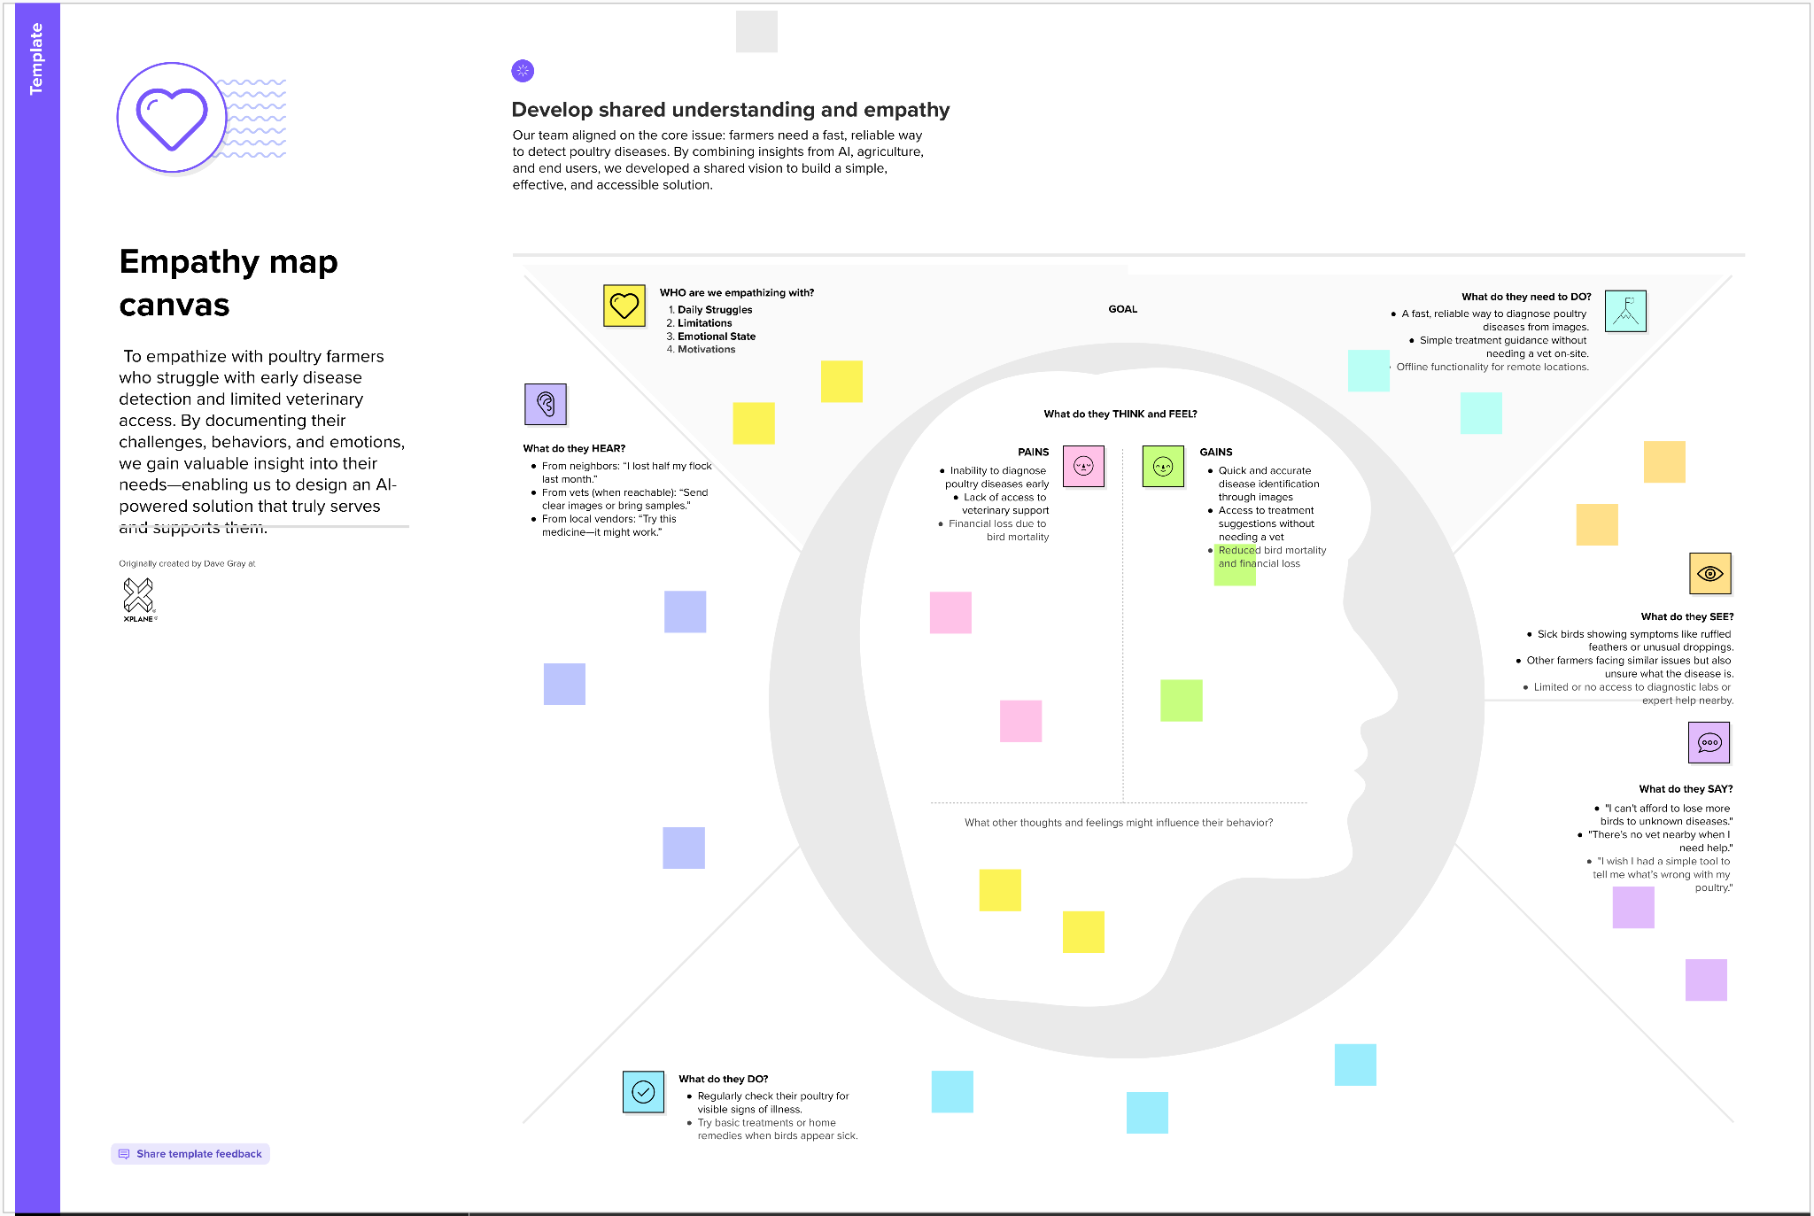

Reference: <https://www.mural.co/templates/empathy-map-canvas>

**Example:**

